Exploratory Data Analysis (EDA) Report

Hospital Management Analytics

1. Project Overview
This project focuses on analysing hospital management data by integrating multiple datasets, cleaning inconsistent records, handling missing values, performing feature engineering, and conducting Exploratory Data Analysis (EDA). The objective is to prepare a clean analytical dataset for healthcare analysis and business reporting.

2. Project Objectives
- Import and inspect multiple hospital datasets.
- Clean and preprocess raw data.
- Handle missing values and duplicate records.
- Standardize inconsistent data.
- Merge datasets into a unified analytical dataset.
- Create new features for analysis.
- Calculate healthcare KPIs.
- Perform exploratory data analysis using visualizations.

3. Dataset Description
The project consists of five datasets.
Dataset | Description
Patients | Patient demographic and health information
Admissions | Hospital admission and discharge details
Doctors | Doctor information and experience
Hospitals | Hospital details including ratings and beds
Treatments | Disease, medicine, and billing information

4. Libraries Used
- Pandas
- NumPy
- Matplotlib
- Seaborn


5. Data Loading
- Imported all datasets using Pandas.
- Stored each dataset in separate DataFrames.
- Performed initial inspection using DataFrame functions.
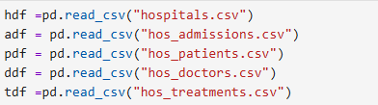

6. Data Cleaning
The following preprocessing steps were performed:

Data Inspection
- Checked dataset dimensions.
- Checked column names.
- Checked data types.
- Inspected missing values.
- Checked duplicate records.
- Verified unique values.


Missing Value Treatment
- Filled missing Hospital Rating values.
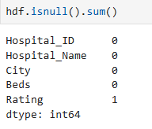
- Filled missing Recovery Days.
- Estimated missing Discharge Dates.
- Filled missing Bill Amount values.
- Filled missing Age values.
- Filled missing Height values.
- Filled missing Weight values.
- Filled missing Diabetes values.
- Filled missing Smoking Status values.
- Filled missing Doctor Experience values.

Duplicate Handling
- Removed duplicate Doctor Records.
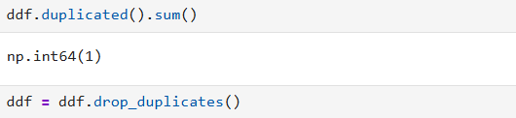

Data Type Conversion
- Converted Admission Date into date time format.
- Converted Discharge Date into date time format.
- Corrected numerical data types where required.

Data Standardization
- Standardized Gender values.
- Corrected Disease names.
- Corrected Medicine names.
- Removed unwanted spaces.

Data Validation
- Checked invalid Age values.
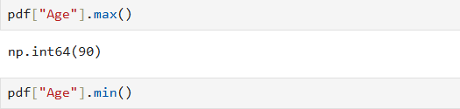
- Validated Hospital Ratings.
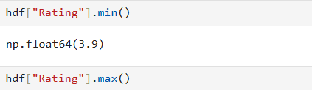
- Verified Recovery Days.
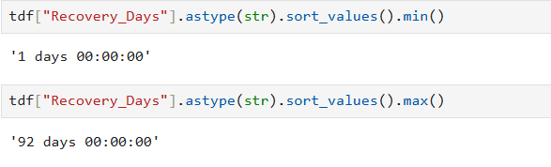

7. Data Integration
Merged the following datasets into a single analytical dataset.
- Admission
- Treatment

8. Feature Engineering
Created the following new features:
- Age Group
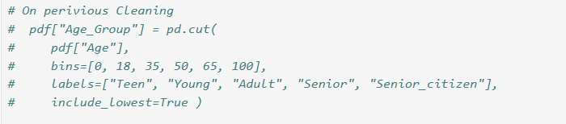
- BMI

9. Business KPIs
The following KPIs were calculated:
- Total Patients
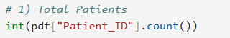
- Total Hospitals
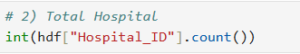
- Total Doctors
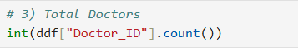
- Total Revenue
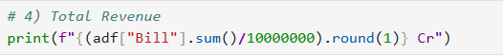
- Total Beds
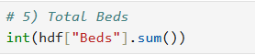
- Average Bill Amount
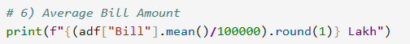
- Average Patient Age
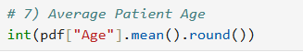
- Average Recovery Days
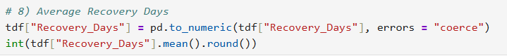
- Average BMI
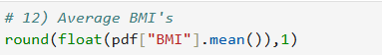
- Average Hospital Rating
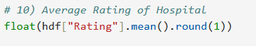
- Average Doctor Experience
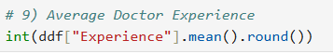
- Average Daily Revenue
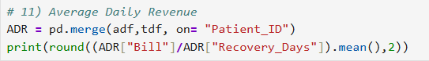
- Diabetes Rate
- Smoking Rate
- Healthy BMI Percentage
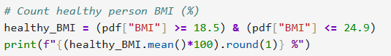
- Highest Billing Hospital
- Highest Revenue Department

10. Exploratory Data Analysis

Patient Count by Disease
Purpose
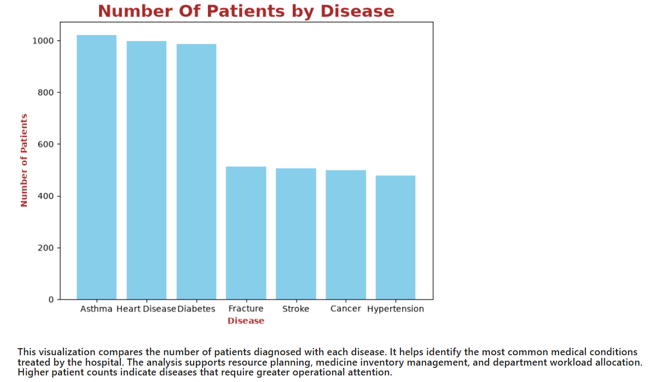

Patient Distribution by Age Group
Purpose
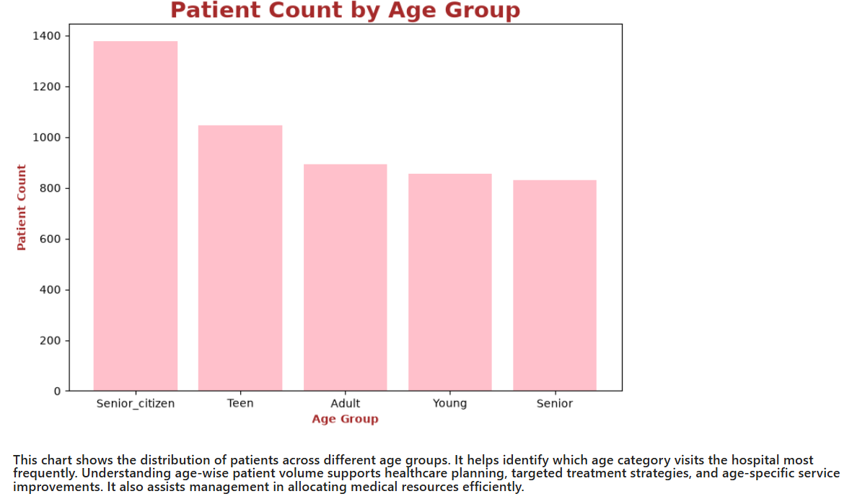

Monthly Hospital Admissions
Purpose
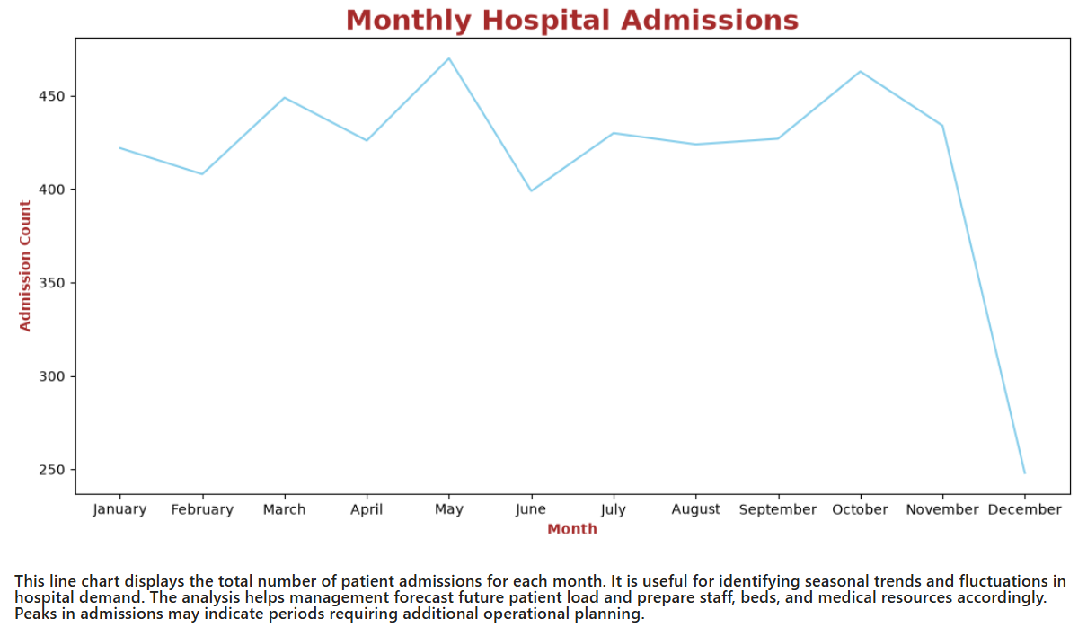

Revenue by Hospital
Purpose
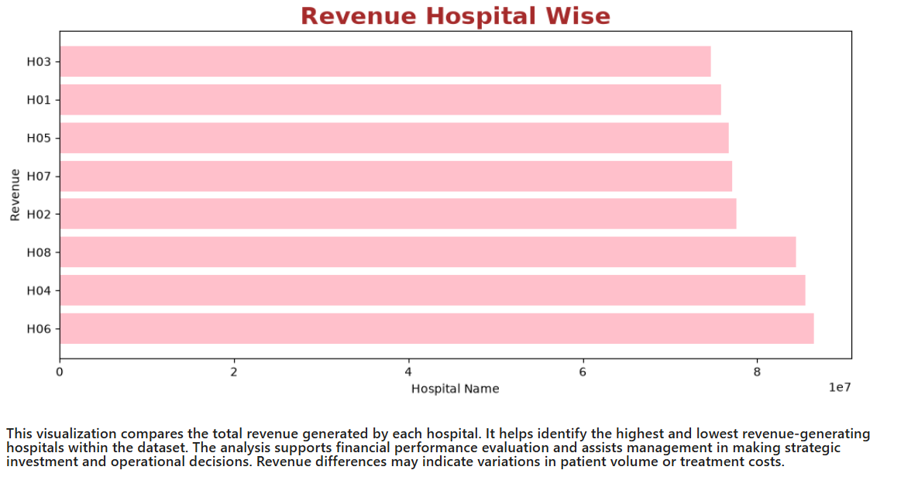

Gender Distribution of Patients
Purpose
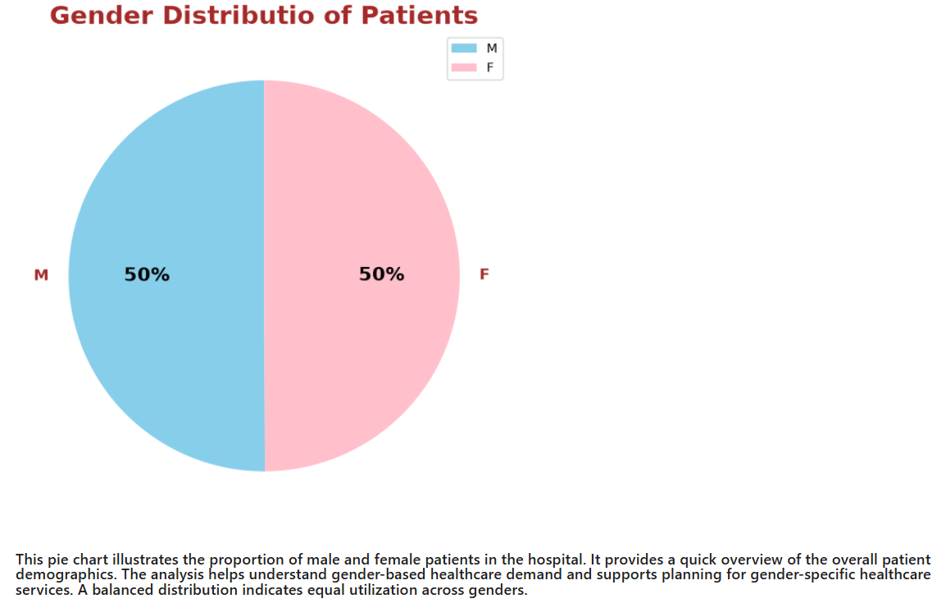

Treatment Cost Distribution
Purpose
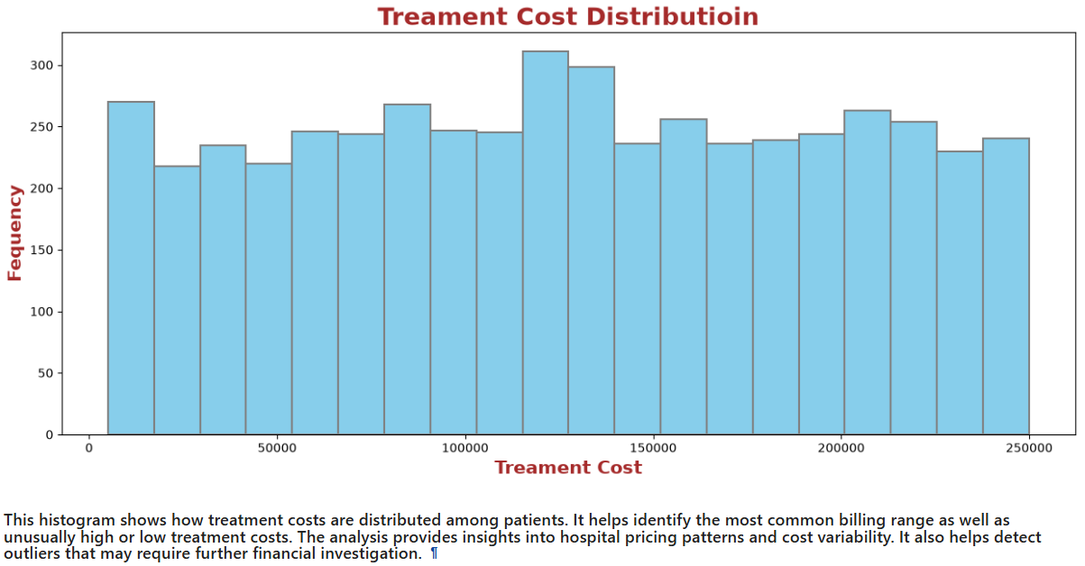

Recovery Days by Department
Purpose
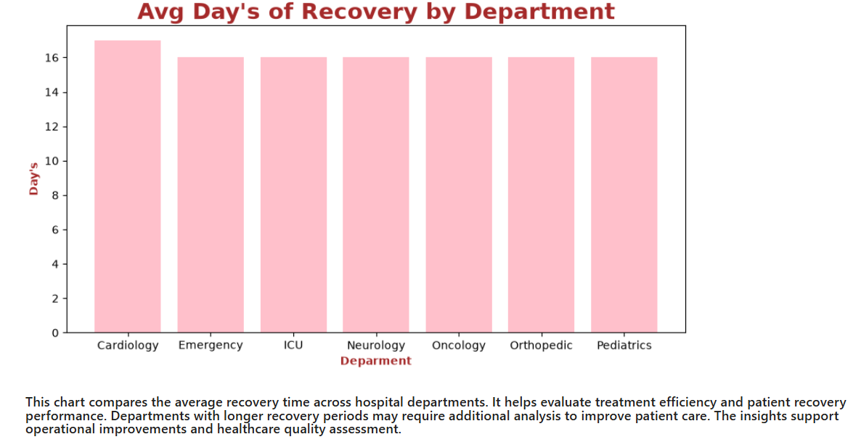

Doctor Count by Department
Purpose
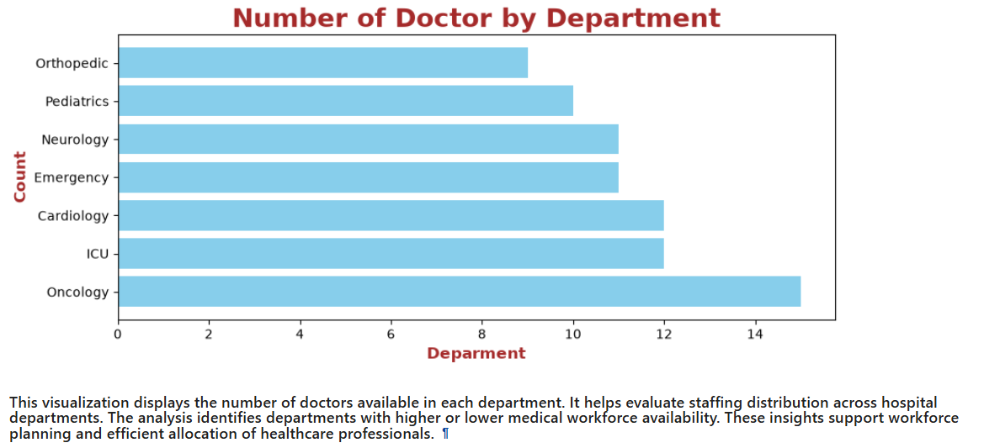

BMI Distribution
Purpose
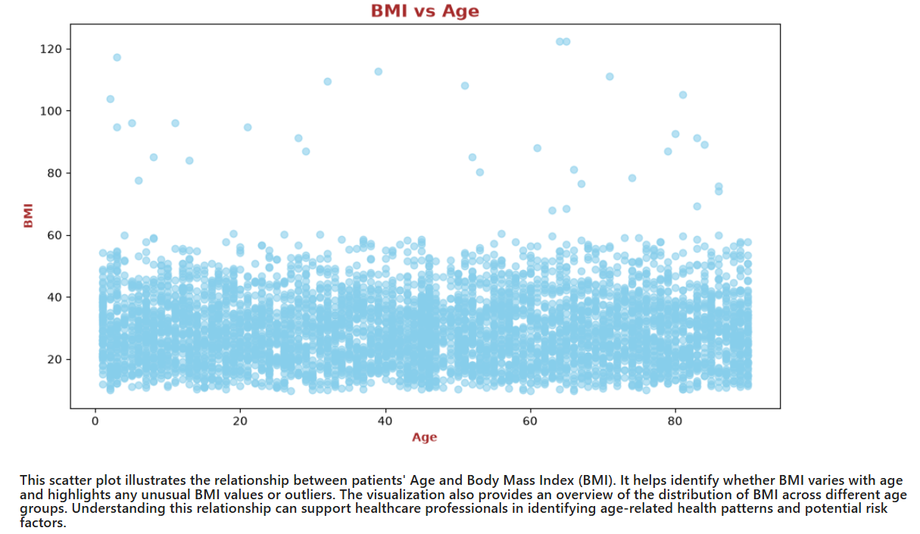

Diabetes and Smoking Status Distribution
Purpose
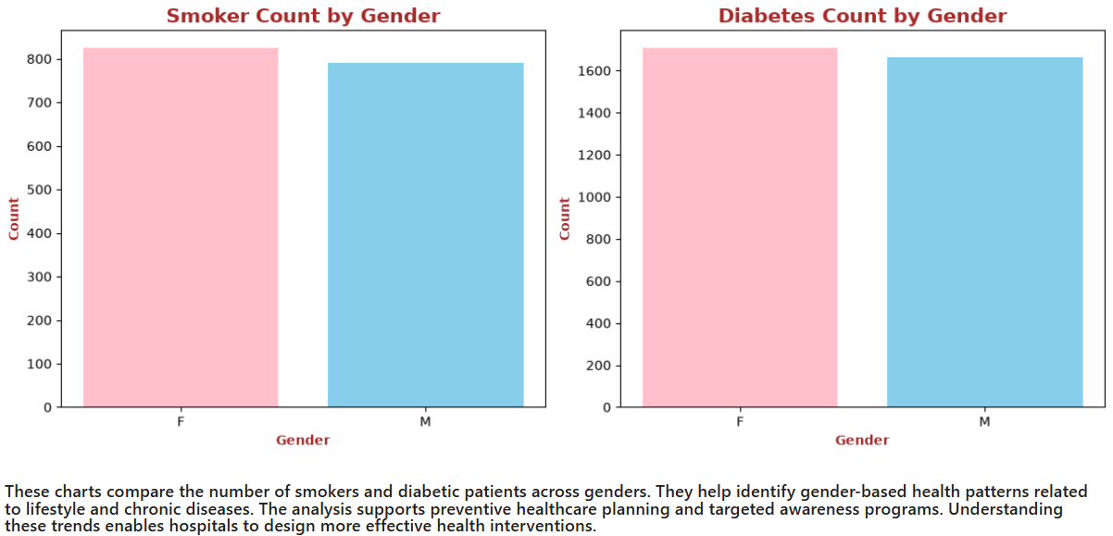

11. Conclusion
•The hospitals generated a total revenue of ₹63.8 Crore, demonstrating strong financial performance across all facilities.

•On average, each patient incurred a medical bill of ₹1.3 Lakh, reflecting the overall treatment cost per admission.

•The average patient age was 45 years, suggesting that most patients belonged to the middle-aged population.

•Patients required an average of 16 recovery days, indicating a moderate average treatment and recovery duration.

•Doctors had an average of 20 years of experience, highlighting a highly experienced medical workforce.

•The hospitals maintained an average rating of 4.2 out of 5, indicating a high level of patient satisfaction.

•The average daily revenue generated per patient was approximately ₹13,248, reflecting efficient revenue generation during hospitalization.

•The average patient BMI was 29.7, which falls in the overweight category and indicates an increased health risk among the patient population.

•67.4% of patients had diabetes, showing that diabetes was highly prevalent and represented a major health concern.

•32.3% of patients were smokers, suggesting that nearly one-third of the patients had a lifestyle risk factor associated with various diseases.

•Only 21.3% of patients had a healthy BMI, indicating that the majority of patients were either underweight or overweight/obese.

•Hospital H06 generated the highest billing, contributing ₹86.49 Lakh, making it the top revenue-generating hospital in the network.

•The ICU department generated the highest revenue of ₹98.29 Lakh, highlighting the significant financial contribution of critical

